## Library Module – Static Library

1. Create 3 files as below. Let cal_utility.c, .h files be part of the library
   1. libapplication.c – will contain main() and will invoke functions in cal_utility.c

Ans)

* 1. cal_utility.c – will contain atleast 2 or more functions [ You may add definitions of the functions in this file ]

Ans)

* 1. cal_utility.h – will contain the extern declarations/prototypes of the functions in cal_utility.c

Ans)

1. Refer the steps for static library based application and create a static library application using above set of files.

Ans) ar rcs -o libcal.a cal_utility.o 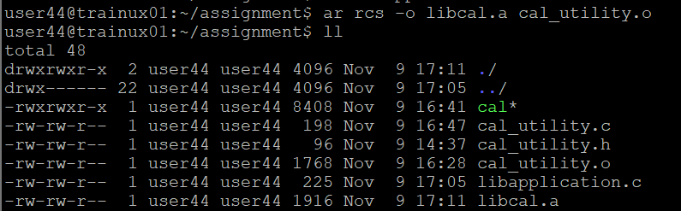

1. Execute the application created in step #2

Ans) gcc libapplication.c -L ./lcal -o stcal

./stacl

